BUTTERWORTH FILTER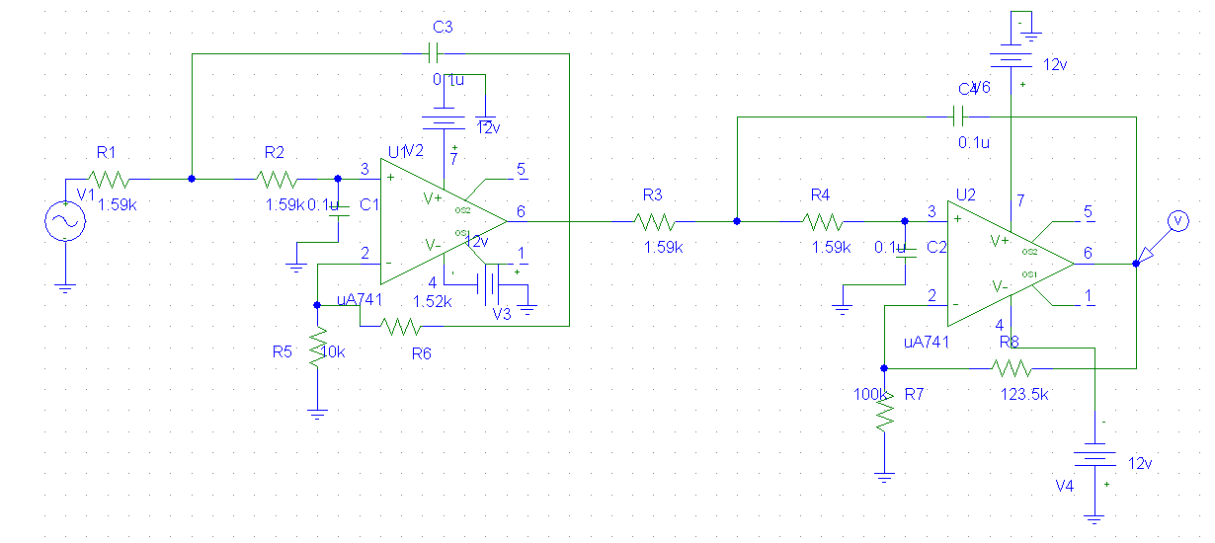

BUTTERWORTH FILTER
AC RESPONSE
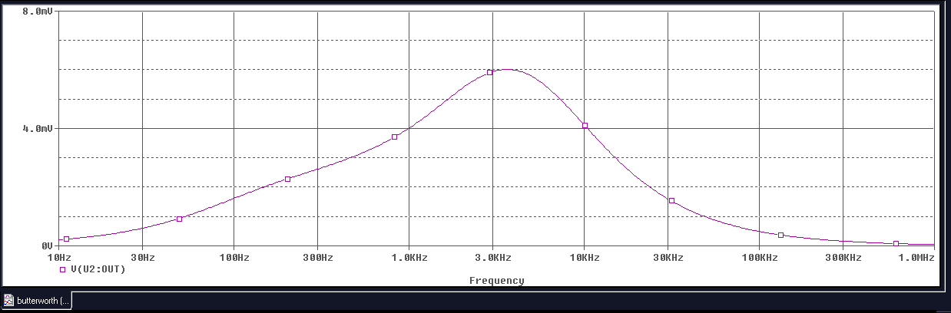

TRANSIENT RESPONSE
