EXP NO :1

TO PERFORM GENERATION & TRANSMISSION OF BASIC CONTINUOUS SIGNALS

PROGRAM FOR SINE WAVE :

x= 0:0.01:6.5;
y= sin(x);
plot (x,y)
grid on

OUTPUT WAVEFORM :

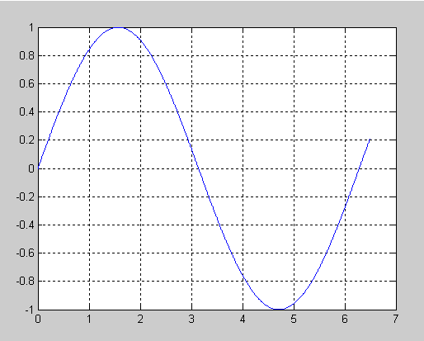
2) PROGRAM FOR COS WAVE :

x=0:0.01:5.5;
y=cos(x);
plot (x,y)
grid on
xlabel ('time')
ylabel ('amplitude')

OUTPUT WAVEFORM :

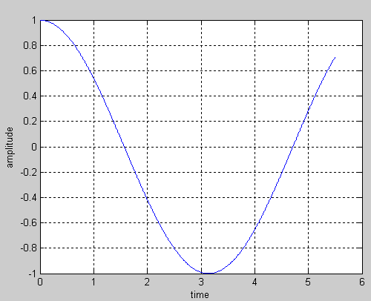

3) PROGRAM FOR RAMP SIGNAL :

x=0:0.01:5.5;
y=(x);
plot (x,y)
grid on
xlabel ('time')
ylabel ('amplitude')

OUTPUT WAVE FORM :

