4 BIT BARREL SHIFTER USING STRUCTRAL
library IEEE;
use IEEE.STD_LOGIC_1164.ALL;
use IEEE.STD_LOGIC_ARITH.ALL;
use IEEE.STD_LOGIC_UNSIGNED.ALL;
---- Uncomment the following library declaration if instantiating
---- any Xilinx primitives in this code.
--library UNISIM;
--use UNISIM.VComponents.all;
entity MUX41CASE is
Port ( SEL : in STD_LOGIC_VECTOR (01 downto 0);
D : in STD_LOGIC_VECTOR (03 downto 0);
Y : out STD_LOGIC);
end MUX41CASE;
architecture Behavioral of MUX41CASE is
begin
PROCESS (D,SEL)
BEGIN
CASE SEL IS
WHEN "00" => Y <= D(0);
WHEN "01" => Y <= D(1);
WHEN "10" => Y <= D(2);
WHEN "11" => Y <= D(3);
WHEN OTHERS => Y <= 'Z';
END CASE;
END PROCESS;
end Behavioral;
----------------------------------------------------------------------------------
library IEEE;
use IEEE.STD_LOGIC_1164.ALL;
use IEEE.STD_LOGIC_ARITH.ALL;
use IEEE.STD_LOGIC_UNSIGNED.ALL;
---- Uncomment the following library declaration if instantiating
---- any Xilinx primitives in this code.
--library UNISIM;
--use UNISIM.VComponents.all;
entity barrel4structri8 is
Port ( D : in STD_LOGIC_VECTOR (03 downto 0);
SEL : in STD_LOGIC_VECTOR (01 downto 0);
Y : out STD_LOGIC_VECTOR (03 downto 0));
end barrel4structri8;
architecture STRUCTURAL of barrel4structri8 is
COMPONENT MUX41CASE is
Port ( SEL : in STD_LOGIC_VECTOR (01 downto 0);
D : in STD_LOGIC_VECTOR (03 downto 0);
Y : out STD_LOGIC);
end COMPONENT;
signal t1,t2,t3: std_logic_vector(3 downto 0);
begin
t1 <= d(0) & d(3 downto 1);
t2 <= d(1 downto 0) & d(3 downto 2);
t3 <= d(2 downto 1) & d(0) & d(3);
U1 : MUX41CASE port map (SEL (1 downto 0), d(3 downto 0), y(0));
U2 : MUX41CASE port map (SEL (1 downto 0), t1 , y(1));
U3 : MUX41CASE port map (SEL (1 downto 0), t2 , y(2));
U4 : MUX41CASE port map (SEL (1 downto 0), t3 , y(3));
end STRUCTURAL;

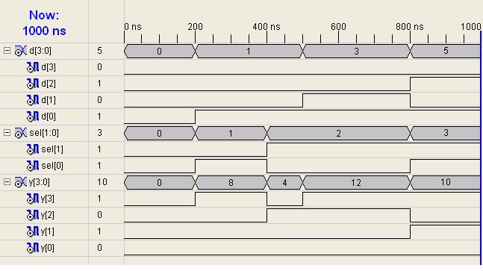
FA USING HA AS A COMPONENT

library IEEE;
use IEEE.STD_LOGIC_1164.ALL;
use IEEE.STD_LOGIC_ARITH.ALL;
use IEEE.STD_LOGIC_UNSIGNED.ALL;

entity ha is
port ( aa,ba :in std_logic;
ya,co : out std_logic);
end ha;

architecture dataflow of ha is
begin
ya <= aa xor ba;
co <= aa and ba;
end dataflow;
---------------------------------------
library IEEE;
use IEEE.STD_LOGIC_1164.ALL;
use IEEE.STD_LOGIC_ARITH.ALL;
use IEEE.STD_LOGIC_UNSIGNED.ALL;

entity or1 is
port ( ab,bb :in std_logic;
yb : out std_logic);
end or1;

architecture dataflow of or1 is
begin
yb <= ab or bb;
end dataflow;
---------------------------------------
library IEEE;
use IEEE.STD_LOGIC_1164.ALL;
use IEEE.STD_LOGIC_ARITH.ALL;
use IEEE.STD_LOGIC_UNSIGNED.ALL;

entity fausingha is
Port ( a,b,cin : in STD_LOGIC;
y,co : out STD_LOGIC);
end fausingha;

architecture structural of fausingha is
component ha is
port ( aa,ba :in std_logic;
ya,co : out std_logic);
end component;
component or1 is
port ( ab,bb :in std_logic;
yb : out std_logic);
end component;
signal op1,co1,co2 : std_logic;

begin
u1: ha port map (a,b,op1,co1);
u2: ha port map (op1,cin,y,co2);
u3: or1 port map (co2,co1,co);
end structural;

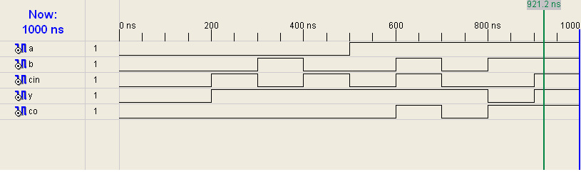

BCD TO EXCESS3:

library IEEE;
use IEEE.STD_LOGIC_1164.ALL;
use IEEE.STD_LOGIC_ARITH.ALL;
use IEEE.STD_LOGIC_UNSIGNED.ALL;

entity BCDTOEX3 is
Port ( D : in STD_LOGIC_VECTOR (03 downto 0);
Y : out STD_LOGIC_VECTOR (03 downto 0));
end BCDTOEX3;

architecture Behavioral of BCDTOEX3 is
begin
Y <= D + "0011";
end Behavioral;