Exp no 1 NMOS inverter with resistive load
Circuit diagram
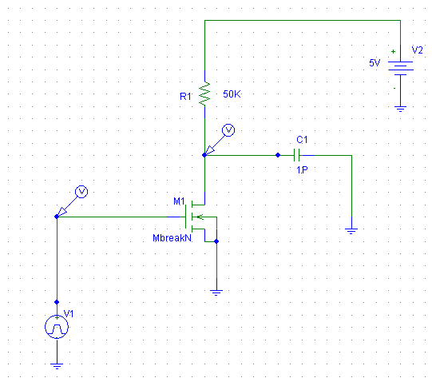

DC Response
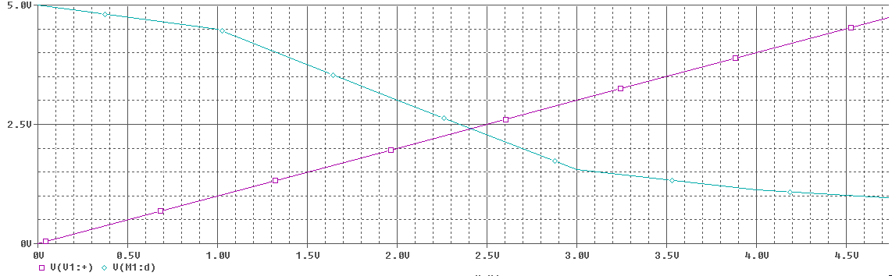

Transient response v1=5V, v2=0V
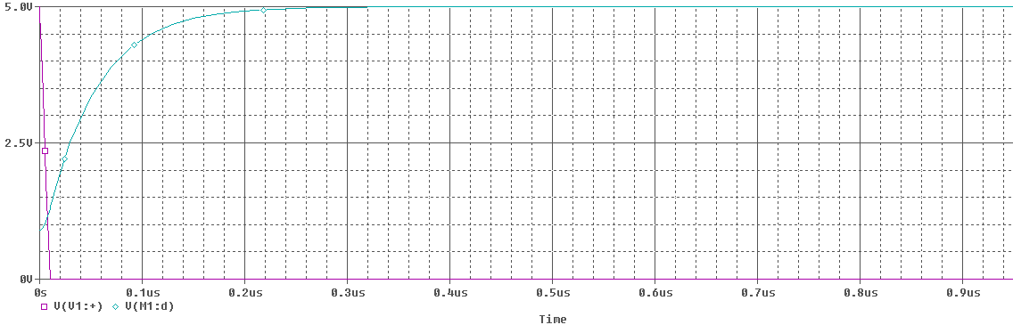
Transient Response V1=0V, V2=5V
