Exp No. 2 NMOS INVERTER WITH DEPLETION LOAD
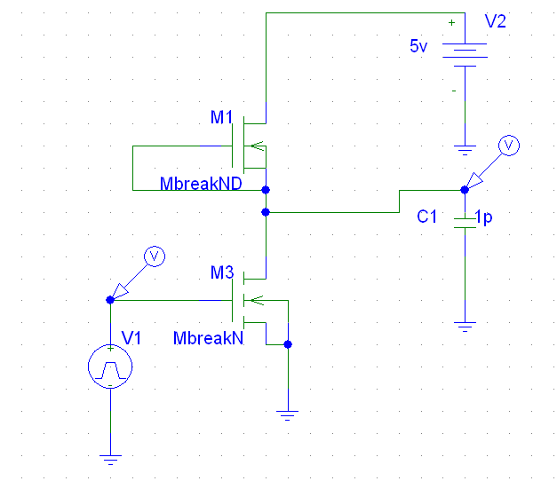
DC RESPONSE
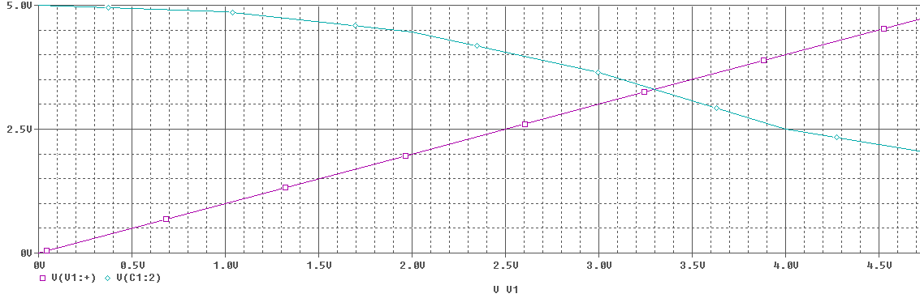

TRANSIENT RESPONSE
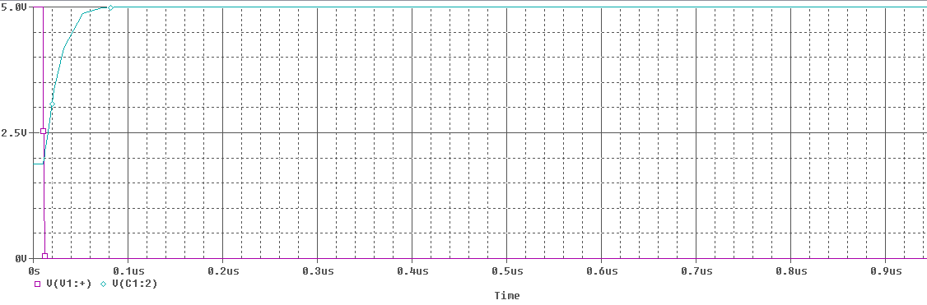
TRANSIENT RESPONSE
