EXP NO 3 NMOS INVERTER WITH ENHANCEMENT LOAD

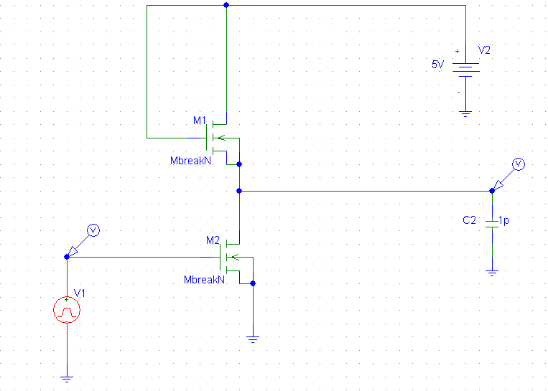

DC SWEEP
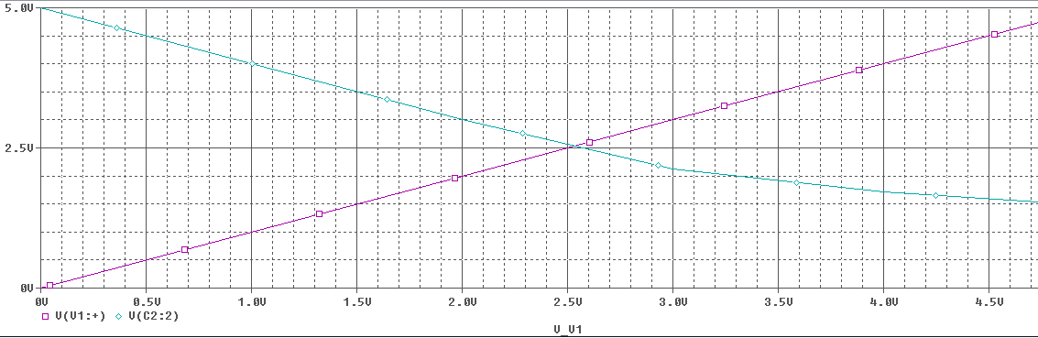

TRANSIENT RESPONSE
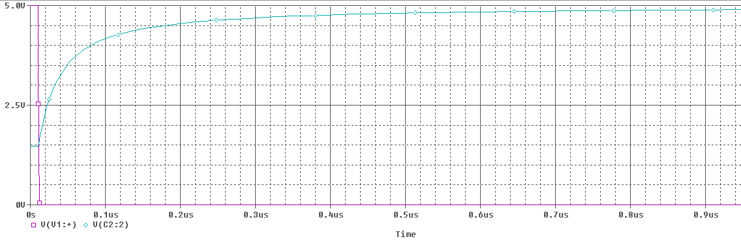

TRANSIENT RESPONSE
