EXP NO 4 CMOS INVERTER

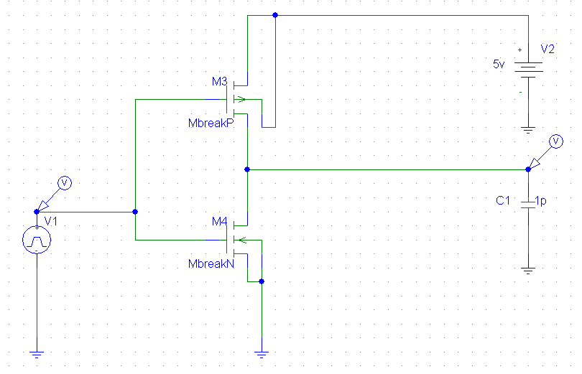

DC RESPONSE
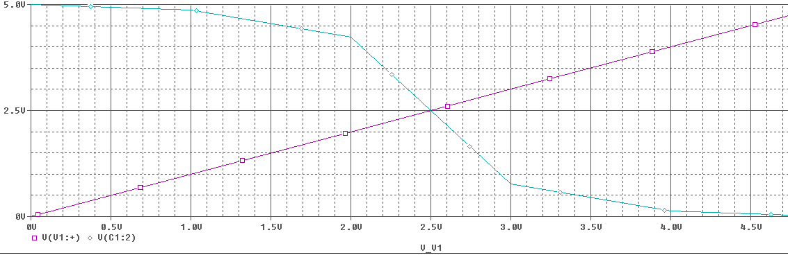

TRANSIENT RESPONSE
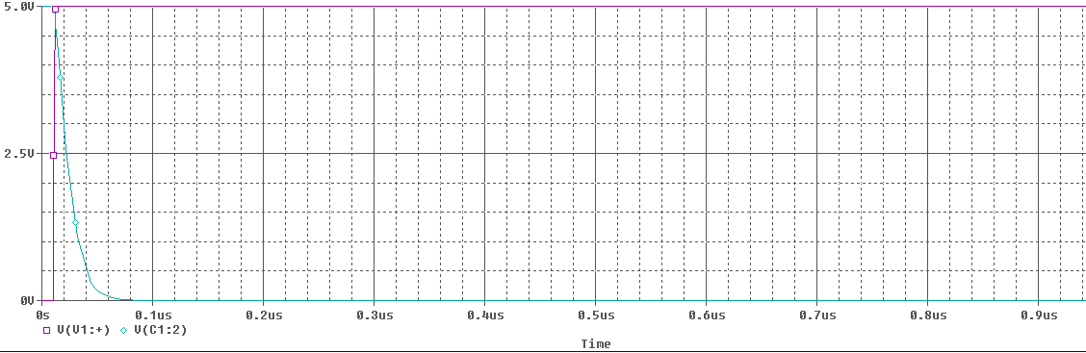
TRANSIENT RESPONSE
