**FWR Controlled**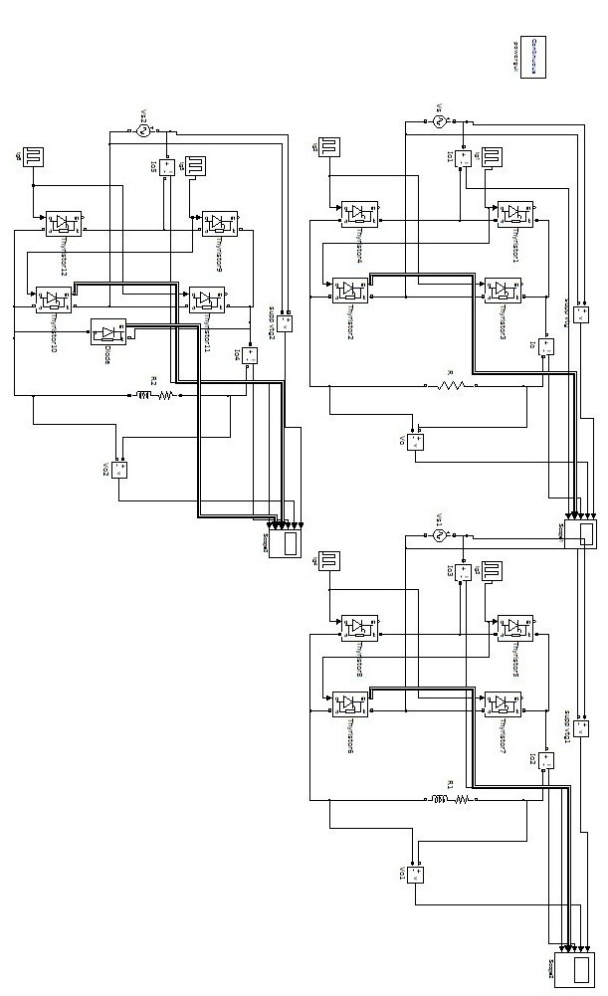

**FWR Controlled (for R load)**

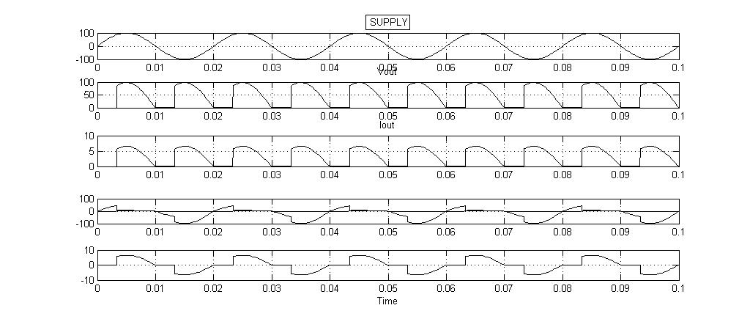

**FWR Controlled (for RL load)**

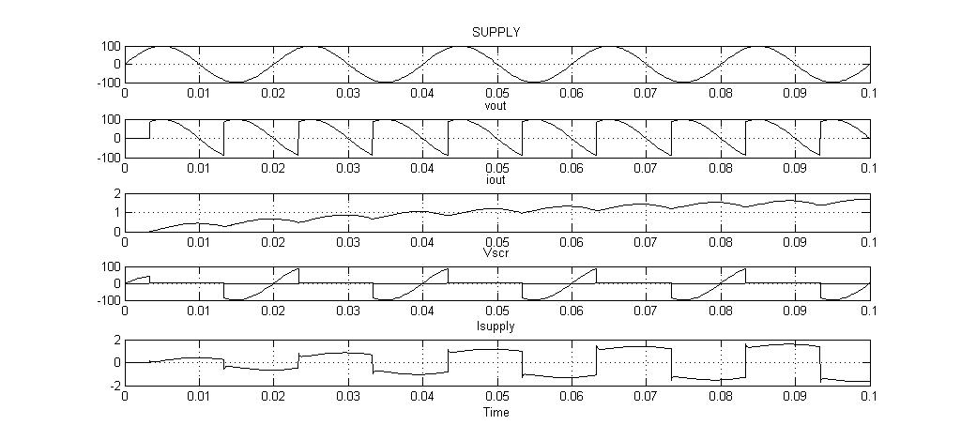

**FWR Controlled (for RL load with FD)**

