INTEGRATOR:
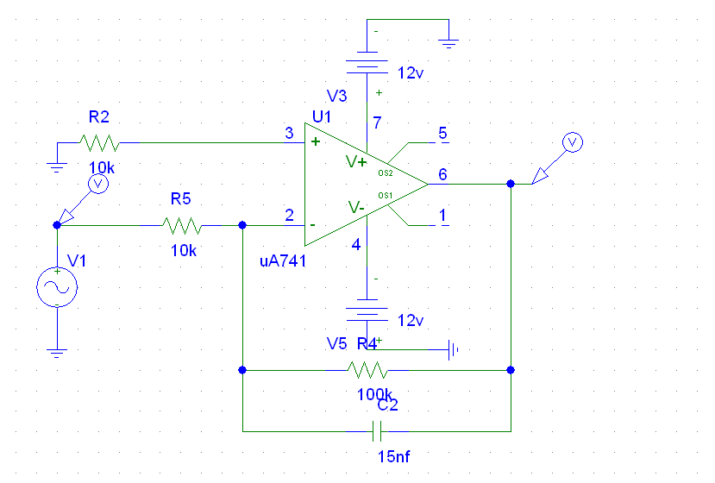

AC RESPONSE:
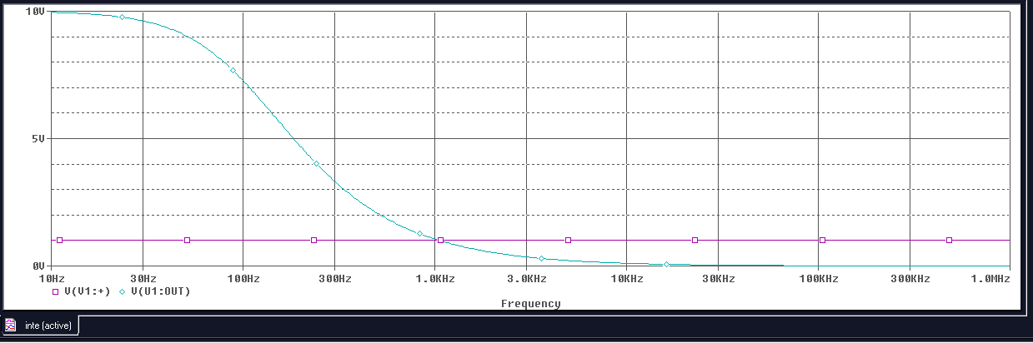

TRANSIENT RESPONSE:
